2026 Master’s Thesis

Eigen-Politics: A Spectral Analysis of the US Senate

Quantitative Methods in the Social Sciences Graduate School of Arts and Sciences
Academic Supervisor: Gregory Eirich
Name: Maximilian Chelminski

Abstract
This thesis investigates the historical and contemporary network topology of the United States Senate to determine whether the chamber has undergone a mathematical phase transition from a cohesive deliberative body to a disconnected bipartite graph. While traditional spatial models like DW-NOMINATE excel at measuring ideological distance, they cannot adequately quantify the structural fragility of the legislative network. By applying Spectral Graph Theory to roll-call voting matrices from the 1st through the 119th Congresses (1789–2026), this research measures the exact algebraic connectivity of the Senate. The eigendecomposition of the normalized Laplacian reveals an unprecedented collapse in the network’s Fiedler value (λ₂) following the 1994 Gingrich Revolution, culminating in a historically low value of 0.269 in the 119th Senate. This algebraic decay is physically corroborated by a plummeting empirical Cheeger constant (h_{G}), indicating the near-total elimination of cross-aisle legislative bridges. Furthermore, tracking maximum betweenness centrality (BC_{max}) exposes the extinction of the “moderate broker,” replaced initially by isolated “monopoly gatekeepers,” before ultimately dropping to zero as the network completely fractured in early 2026. Modeled through the lens of Markov chain dynamics, the extreme relaxation and hitting times of the contemporary Senate mathematically prove that the structural capacity for a “random walk of legislative persuasion” to cross party lines has been effectively eliminated. Ultimately, this thesis demonstrates that the modern Senate has been topologically split into two isolated components, which fundamentally breaks the multi-dimensional, consensus-building mechanism envisioned by the authors of the Constitution.

Table of Contents
1 Introduction 4
2 Hypotheses 7
3 Literature Review 8
4 Data Collection and Methodology 14
5 Analysis 19
6 Results 30
7 Discussion 34
8 Conclusion 38
Limitations 39
References 41

List of Tables, Figures, and Appendices
Figure 5.1 19
Figure 5.2 20
Figure 5.3a 21
Figure 5.3b 22
Figure 5.4 23
Figure 5.5a 24
Figure 5.5b 25
Figure 5.6 26
Figure 5.7a 27
Figure 5.7b 28
Table 6.1 33

1 Introduction
The contemporary United States Senate is often characterized in discourse by its severe partisan gridlock, institutional dysfunction, and an apparent inability to forge bipartisan consensus. Observers of modern American politics frequently note that the gap between the Democratic and Republican parties has widened to historic extremes. However, this thesis argues that characterizing this divide merely as a “widening gap” fundamentally misrepresents the nature of the crisis. A mere gap holds the implication that the space between two opposing factions still exists and can be traversed, even if doing so is politically difficult. This thesis proposes that the Senate is not merely polarized across a spatial plane, but it instead has suffered a structural dimensionality collapse. The legislative network has undergone a topological phase transition, shifting from a fluid, multi-dimensional space connected by overlapping interests into a brittle, one-dimensional bipartite graph where the “connective tissue” between the parties has been mathematically severed.
Traditional political science literature has long relied on spatial scaling algorithms, most notably DW-NOMINATE (Poole and Rosenthal 1985), to quantify Senate polarization. These models place legislators on a continuous Euclidean plane, successfully proving that the ideological distance between the median Democrat and the median Republican has expanded significantly over the last several decades. Yet, these spatial models operate on an assumption of continuous space that is always able to be traversed. They map the distance between actors but lack the mathematical vocabulary to describe the literal severing of relationships, the appearance of structural bottlenecks that emerge as the center hollows out, or the physical “cuttability” of the aggregate legislative network. When the Senate is evaluated purely as a collection of coordinate points, the fragility of the institution remains obscured.
To bridge this methodological gap, this thesis models the Senate as a discrete relational topology in a network. By constructing weighted adjacency matrices representing the roll-call voting correlations of every pair of Senators for every Congress from 1789 to 2026, the Senate is transformed into a network graph. We then utilize Spectral Graph Theory, specifically the eigendecomposition of the normalized Laplacian matrix to extract the Fiedler value (λ₂) to establish a strict algebraic metric of the graph’s connectivity. This macro-level structural analysis is subsequently paired with the empirical Cheeger constant (h_{G}) to quantify the physical bottleneck between the parties, and maximum betweenness centrality (BC_{max}) to track the micro-level distribution of legislative brokerage power among individual Senators. Finally, to translate these static network metrics into the dynamic reality of legislative procedure, the Senate is modeled as a Markov chain, utilizing relaxation time and hitting time to calculate the mathematical probability of cross-aisle cooperation in voting.
The subsequent sections of this thesis are structured to systematically prove this topological collapse. Section 2 formally outlines the hypotheses regarding the Senate’s phase transition and the monopolization of gatekeeping power. Section 3 provides a comprehensive review of the existing literature on Senate polarization, institutional procedure, and the application of network science to legislative bodies. Section 4 details the data collection process from Voteview and rigorously defines the mathematical instruments of Spectral Graph Theory and Markov chain dynamics deployed in this research. Section 5 visualizes the historical decay of the Senate’s spectral geometry, reveals the movement of the Fiedler value, the Cheeger constant, and the rise of the monopoly broker (and its sudden collapse) over two centuries of American history. Section 6 presents the exact empirical results, directly contrasting the healthy, multi-dimensional topology of the 96th Senate (1979-1981) with the fractured reality of the 119th Senate (2025-2027). Section 7 elevates these mathematical findings to democratic theory, discussing how the Senate’s topological collapse represents the systemic failure of the Madisonian republic outlined in Federalist No. 10. Finally, Section 8 summarizes the conclusions of the research, addresses the limitations of utilizing roll-call data within a highly engineered procedural environment, and outlines avenues for future network-based political research.

2 Hypotheses
This thesis poses the question: has the United States Senate undergone a topological phase transition? Specifically, to what extent can Spectral Graph Theory demonstrate that the Senate’s legislative network has collapsed from a multi-dimensional, connected space into a disconnected, one-dimensional bipartite graph? Additionally, how has the distribution of “brokerage power” (measured via betweenness centrality) in the network shifted during this transition, and does it indicate an increasingly monopolized gatekeeping structure for passing bills? And, in contrast, to what extent is this effect attributable to the shifting of Senate norms and procedures? The null hypothesis would be that the Senate was always generally polarized, but that the gap has simply widened, or that the effects are being amplified by dramatic shifts in Senate procedure. The proposed alternative hypothesis is that the Senate has suffered a dimensionality collapse where the geometry has fundamentally changed. This specifically means that rather than there simply being a vague “wide gap” between the ideologies of Senators between parties, that the “connections” between them are fundamentally broken, and that modern bills have to pass through a small number of “detractors” who are not completely tied to party lines.

3 Literature Review
The single most critical source for the modern US polarization literature are the works of Keith Poole and Howard Rosenthal who developed the Dynamic Weighted Nominal Three-step Estimation (DW-NOMINATE) method that now dominates the polarization literature (Poole and Rosenthal 1985). DW-NOMINATE is a spatial scaling algorithm that places legislators on a continuous Euclidean plane based on their ideal points. While this method excels at measuring ideological distance, it is not designed to quantify the fragility, or cuttability of the legislative body. As researchers observe phenomena like “conflict extension” (Layman 2010), where issues that may have once been orthogonal collapse to a smaller number of dimensions fueled by a hyper-partisan divide, the need for a method that models the senate as a discrete geometric topology becomes apparent. In a traditional spatial model like DW-NOMINATE, as political parties polarize, they simply move further away from each other on the relevant axes. However, the space between them for “bridge building” still exists, but it is just unoccupied. A topological model does not maintain that space, when two nodes in the graph are too far apart, the edge or relationship between them fractures and the graph is fundamentally less connected. Spectral Graph Theory allows us to precisely quantify when relationships fracture and to understand how the Senate operates as a relational network, rather than a plot of points that are spaced at an arbitrary distance between each other.
The DW-NOMINATE methodology has been used extensively in the literature to demonstrate a historical correlation between economic inequality and partisan polarization (McCarty, Poole, and Rosenthal 2006). Indeed, the spatial model is effective and useful for mapping this macro trend of ideological drift, yet it is not able to deduce the extent to which it is possible for legislation to actually pass in such a polarized environment.
Spectral Graph Theory based methodology has been employed in this context by (Froyland 2025) which applies different Laplace methods to the same context of US Senate polarization. This thesis will build upon Froyland’s spectral methodology, however, rather than using his time-expanded supra-Laplacian, this thesis will calculate the normalized Laplacian independently for each consecutive Congress. This approach will allow for the analysis of each Congress using traditional graph theory metrics, like the Fiedler Value and betweenness centrality to quantify the historical decay of “brokerage power” and the increasing fragility of the Senate during this proposed “topological phase transition.” It addresses the weaknesses of DW-NOMINATE by modeling the Senate as a topological network, which allows us to mathematically measure structural bottlenecks and the risk of the network collapsing into disconnected party bubbles. Still, as measures of polarization, this thesis expects the results of a Spectral Graph Theory analysis to correlate strongly with DW-NOMINATE based results. Similar research using network-based methods of analysis (niche-overlap networks) on roll call voting data and finding similar striking results of dimensionality reduction in recent US legislative history (Schoch 2020). Schoch precisely writes about some of the advantages of this network based approach: DW-NOMINATE forces legislators and their political positions into points onto a space of “political ideology,” while network-based methods mold legislators and their positions into overlapping intervals within a discrete topology. This allows us to represent all relational data between Senators without dropping information. By treating roll call data as such, Schoch empirically demonstrates the same striking collapse in the dimensionality in recent US legislative voting as seen in the literature. This reinforces this thesis, as it demonstrates the potential for modeling the modern collapse of the Senate by evaluating it as a relational network rather than a spatial plane.
However, roll call voting results are also not necessarily indicative of extreme ideological polarization, as changes in voting parity can also be explained by shifting norms, logistics, and expectations in the Senate. Indeed, the literature has observed a number of significant shifts, such as the evolution of the filibuster. Specifically, the 1970 institution of the “two-track” system changed Senate procedure such that a filibuster would no longer stop all business in the Senate, but instead only stop the proceedings for that specific bill. This meant that both the political and logistical cost of filibustering was effectively eliminated. Invoking the filibuster would soon become the norm, and thus the 60 votes needed to close “debate” would become the main barrier to actual voting on bills (Wawro and Schickler 2006). This will combine in effect with omnibus bills, which this thesis discusses below, to essentially “force” the appearance of polarization, even if ideologies may not necessarily be polarized.
Because the filibuster effectively guarantees that most bills will need to pass through a 60 vote threshold, this contributed to the birth of another modern trend in the US legislature: so-called “omnibus bills.” Contemporary lawmaking has largely abandoned single-issue bills in favor of packing bills with a wide variety of legislation across a number of different subjects (Krutz 2001), (Sinclair 2016). Trump’s “One Big Beautiful Bill Act” is a key, very recent example of an omnibus bill. By packing bills together with so many different provisions across so many different issues, the individual multidimensional policy preferences have effectively become abstracted into strict, binary, votes by party lines. This is a compelling explanation for the extreme degree of disconnectivity we observe, especially considering that the current 119th Senate has the lowest Fiedler Value in US history. If Senators are not regularly voting on bills covering single issues which should hypothetically be party-agnostic, then it is only natural that the Senate will appear wildly polarized.
Despite evidence that may suggest polarization is a facade brought forth by simple institutional and procedural changes, there is another robust body of literature that confirms external, ideology driven reasons for the structural collapse we are witnessing. (Fowler 2006) introduces a network-based analysis method for the US Congress, establishing that legislation cosponsorship networks, specifically measures of “connectedness,” are predictive indicators of how members of Congress may actually vote even when controlling for ideology and party ties. Because bill cosponsorship exists outside of the aforementioned examples of Congressional procedural shifts, and legislators are free to cosponsor bills with whomever, this suggests that literature which demonstrates that bill cosponsorship is similarly polarized to roll call votes is indicative that the cause of polarization extends beyond simple procedural change, and that roll call voting data indeed reflects true ideological polarization to some extent. Building upon this, this methodology was utilized to analyze the community structure of US Congress. It elucidated a sharp increase in bill cosponsorship polarization which preceded and culminated in the Republican takeover of the 104th Congress (Zhang et al. 2007).
This timing coincides perfectly with the 1994 Gingrich Revolution (also called the Republican Revolution). Named after House Representative Newt Gingrich, this tipping point ended the apparent era of post-WW2 depolarized stability in US Congress. (Theriault and Rohde 2011) found that “almost the entire growth in Senate party polarization since the early 1970s can be accounted for by Republican senators who previously served in the House after 1978—a group we call the ‘Gingrich Senators.’” They document how, under Gingrich’s leadership, Republicans were able to take over both legislative chambers and essentially dismantle the traditional forms of relationships in US Congress, like the “folkways” of apprenticeship, legislative work, specialization, courtesy, reciprocity, institutional patriotism, and influences of conformity (Matthews 1959). This work is often cited when highlighting the extent to which the Senate has changed over the last six decades, as it documented Senators as working together as partners rather than against each other as enemies, like we may observe today. The Senators in the Gingrich Revolution actively worked to dismantle this paradigm, a behavioral phase transition if you will, by discouraging building bridges across the aisle and enforcing strict intraparty discipline.
The existing literature presents a multifaceted view of Senate polarization. We observe that spatial methods like DW-NOMINATE excel in mapping apparent ideological distance between Senators and parties, while the proposed network-based methods allow us to look deeper into the Senate’s structure, and also open the door to different modes of analysis (like bill cosponsorship). Institutional researchers highlight procedural and norm shifts in the Senate which may explain away apparent ideological polarization that is apparent in roll call voting data, but factors like supporting network-based bill cosponsorship analysis and writing on the Gingrich Revolution indicates a genuine sharpening divide in Senate ideologies. Now, we lack a precise network-based mathematical quantification of the Senate’s structural collapse over time. This thesis will bridge that gap by applying Spectral Graph Theory to historical roll call voting data, moving beyond measuring ideological distance to directly measure topological fragility. In doing so, we will mathematically pinpoint the exact timing and severity of the Senate’s apparent phase transition by highlighting the decay of the “moderate broker,” and the rise of the “monopolized gatekeeper.” We will also observe the ultimate near-severing of the Senate into a disconnected, one-dimensional bipartite graph through analysis of the Fiedler Value and eigenvectors.
To fully contextualize the implications of the spectral clustering model, this thesis draws upon the foundational mathematics of Markov chains. The eigenvalues of a graph’s adjacency matrix are linked to the behavior of a random walk across its nodes. In (Lovász 1993), it is proven that the spectral gap, which is the difference between the Fiedler value and the next smallest eigenvalue, directly bounds the mixing time and hitting times of a network. While Lovász’s work is pure math, this thesis seeks to apply this framework to the Senate, treating it as a random walk to essentially proxy the flow of “legislative persuasion.” If the spectral gap widens, Lovász’s proofs tell us that the expected time for information or compromise to traverse the network will scale towards infinity, providing a rigorous framework for proving the death of interparty discourse in the Senate.

4 Data Collection and Methodology
Senate roll call voting data is obtained from https://voteview.com/data, as of May 5th, 2026, which provides live and historical voting data from the US Senate. The site was directed by American Political Scientists Keith Poole and Howard Rosenthal, logging publicly available voting records for analysis. To transition from independent voting records to a relational topology of the Senate, I construct an adjacency matrix based on the voting correlation between all pairs of Senators in each Congress. Because the next step of encoding the data as a network graph requires all correlation values C of the adjacency matrix to be non-negative, I transform the adjacency matrix by modifying C ∈ [-1, 1] to C ∈ [0, 1] by $A=\frac{C+1}{2}$ for all C. This results in a matrix where 0 represents Senators which never vote together, and 1 represents Senators which always vote together. Now that the weighted adjacency matrix A is established, the underlying graph structure of the Senate can be analyzed using Spectral Graph Theory. Specifically, I compute the normalized Laplacian matrix L:
$$L=I-D^{-\frac{1}{2}}AD^{-\frac{1}{2}}$$
where A is the weighted adjacency matrix, I is the identity matrix, and D is the diagonal degree matrix. The normalized Laplacian matrix is methodologically necessary to ensure comparability across different Senates of (slightly) different sizes and different volumes of legislation, while also binding the spectrum of eigenvalues to lie in [0, 2].
Then I perform an eigendecomposition on the normalized Laplacian, which is a matrix representation of the network graph, and the derived eigenvalues and eigenvectors have meaningful interpretations. Specifically, the second smallest eigenvalue λ₂ is the Fiedler Value, and it represents how “connected” the network graph is. If it equals 0, we essentially have two disconnected graphs. If it is small, we have a graph that is almost disconnected (with a bottleneck), and if it is large, the graph is well connected and difficult to cut. The eigenvectors can be interpreted as latent axes of division. While the actual details of the axis are a black box, it is valuable in this sense where we can observe the extent of dimensionality in how Senators vote. While the first eigenvector will almost certainly correspond to party lines and general ideological division, the second eigenvector may correspond to other orthogonal divisions like geographical lines or other intraparty axes.
To understand the implications of the Fiedler value, we must interpret it through the lens of the spectral gap and random walks in Markov chain dynamics. In Spectral Graph Theory, the magnitude of λ₂ binds the mixing time of a random walk across the network in a Markov chain. In the context of the Senate, a random walk can serve as a proxy for the flow of legislative compromise. In a random walk, there is a probability of one node traveling to the next based on the weight of the edge in the network. A high Fiedler value indicates a short mixing time. However, as λ₂ approaches zero, the mixing time approaches infinity according to the following formula where 𝜏_{mix} represents the mixing time required for the random walk to reach its stationary distribution, λ₂ is the Fiedler value, 𝜋_{min} is the minimum stationary probability of any single node (Senator) in the network, and 𝜖 represents the acceptable error threshold or distance from perfect equilibrium.
$$τ_{mix} ≤ \frac{1}{λ_{2}}ln(\frac{1}{π_{\min_{ϵ}}})$$
The item of interest in 𝜏_{mix} is the relaxation time, $\frac{1}{λ_{2}}$, which is the constant that binds the mixing time.
While mixing time evaluates the global convergence of the entire network, this is not able to perfectly model the reality of node-to-node mechanics in real legislative persuasion. For example, if a bill on a random walk does cross over a bottleneck, our mixing time interpretation implies that the bill would then completely mix within that cluster before ever returning to the initial cluster. In reality, bills that “randomly” cross the interparty gap often stop at that singular Senator, and do not mix in their cluster further. This phenomenon can be formally modeled through the network’s hitting time, H(s, t). As detailed by Lovász (1993), the hitting time represents the expected number of steps a random walk must take, starting from an origin node s, which in this case we can interpret as the sponsors of a bill, before visiting a destination node t for the first time. In Theorem 3.1 of his work, Lovász defines the exact spectral formula for hitting time:
$$H(s,t)=2m\sum_{k=2}^{n}{\frac{1}{1-λ_{k}}(\frac{{v^{2}}_{kt}}{d(t)}-\frac{v_{ks}v_{kt}}{\sqrt{d(s)d(t)}})}$$
Crucially, Lovász notes that the presence of 1 - λ_{k} in the denominator dictates that the hitting time is primarily bounded by the network’s spectral gap. Because it is an established algebraic identity that the spectral gap of a random walk transition matrix is strictly equivalent to the Fiedler value of the normalized Laplacian, this equation perfectly encapsulates the hypothesized crisis this thesis seeks to observe. As the Fiedler value declines toward zero, the denominator in Lovász’s formula vanishes. This dictates that the expected number of steps required for a “random walk of persuasion” to bridge the partisan divide scales toward infinity.
Mathematically, this means a random walk often becomes permanently trapped within a single partisan cluster. The probability of cross-party collaboration drops to nearly zero, transforming the legislative process from a fluid network of negotiation into two isolated silos.
This structural division can be further quantified by the empirical Cheeger constant (h_{G}), the graph’s “cuttability,” or conductance in the context of Markov chains. The Cheeger constant measures the optimal bottleneck of the Senate, or the minimum ratio of cross-party edges relative to the total volume of edges within the parties. By Cheeger’s Inequality, we know that the graph’s conductance is bounded by the Fiedler value as follows:
$$\frac{λ_{2}}{2}≤h_{G}≤\sqrt{2λ_{2}}$$
As λ₂ drops, it forces the upper bound of the Cheeger constant down with it. If λ₂ drops, this proves that the modern Senate has been topologically made brittle. If we interpret it as the “surface area” of the partisan divide, a measure of the actual number of shared votes bridging the two parties together, then we would be observing a shrinkage to a historical anomaly where the Senate is more cuttable than ever.
Finally, to evaluate the distribution of individual power within this topology, I calculate the betweenness centrality BC for all nodes v in each Congress:
$$BC(v)=\sum_{s≠t≠v}{\frac{σ_{st}(v)}{σ_{st}}}$$
where σ_{st} is the total number of shortest paths between nodes s and t, and σ_{st}(v) is the number of those paths which pass through node v. We can then interpret nodes with a high betweenness centrality as Senators with significant “brokerage power” in the Senate, those whose votes are critical for passing bills with tight margins. To measure the extent to which this brokerage power is monopolized, this methodology specifically isolates the Maximum Betweenness Centrality for each Congress. The selection of BC_{max} as the primary metric for brokerage is methodologically deliberate. Aggregate metrics, such as mean centrality, become mathematically distorted in highly polarized environments due to the vast majority of senators possessing exactly zero bridging power. BC_{max} however precisely captures the peak concentration of gatekeeping power. In a topologically healthy Senate with a robust, bipartisan middle class, numerous redundant paths exist across the aisle. This distributes brokerage power across many senators, naturally suppressing the maximum individual score. In contrast, when the network fractures, the few remaining moderate ties become structural bottlenecks. As a consequence, a spike in BC_{max} serves as a direct mathematical indicator for the rise of the “monopoly broker,” a state where the Senate’s capacity for compromise rests exclusively on an isolated subset of legislators.

5 Analysis
The primary empirical metric for evaluating the Senate’s topological stability is the Fiedler value (λ₂). The magnitude of λ₂ serves as a strict mathematical bound on the graph’s fragility. If its value approaches zero, this denotes a severely bottlenecked topology, while an exact value of zero indicates a fully disconnected, bipartite structure with multiple components. By performing an eigendecomposition on the normalized Laplacian for every Senate from 1789 to 2026, this analysis reconstructs the decay of the Senate’s connectivity. As visualized in Figure 5.1, the historical trend reveals a severe and unprecedented structural collapse.

Figure 5.1
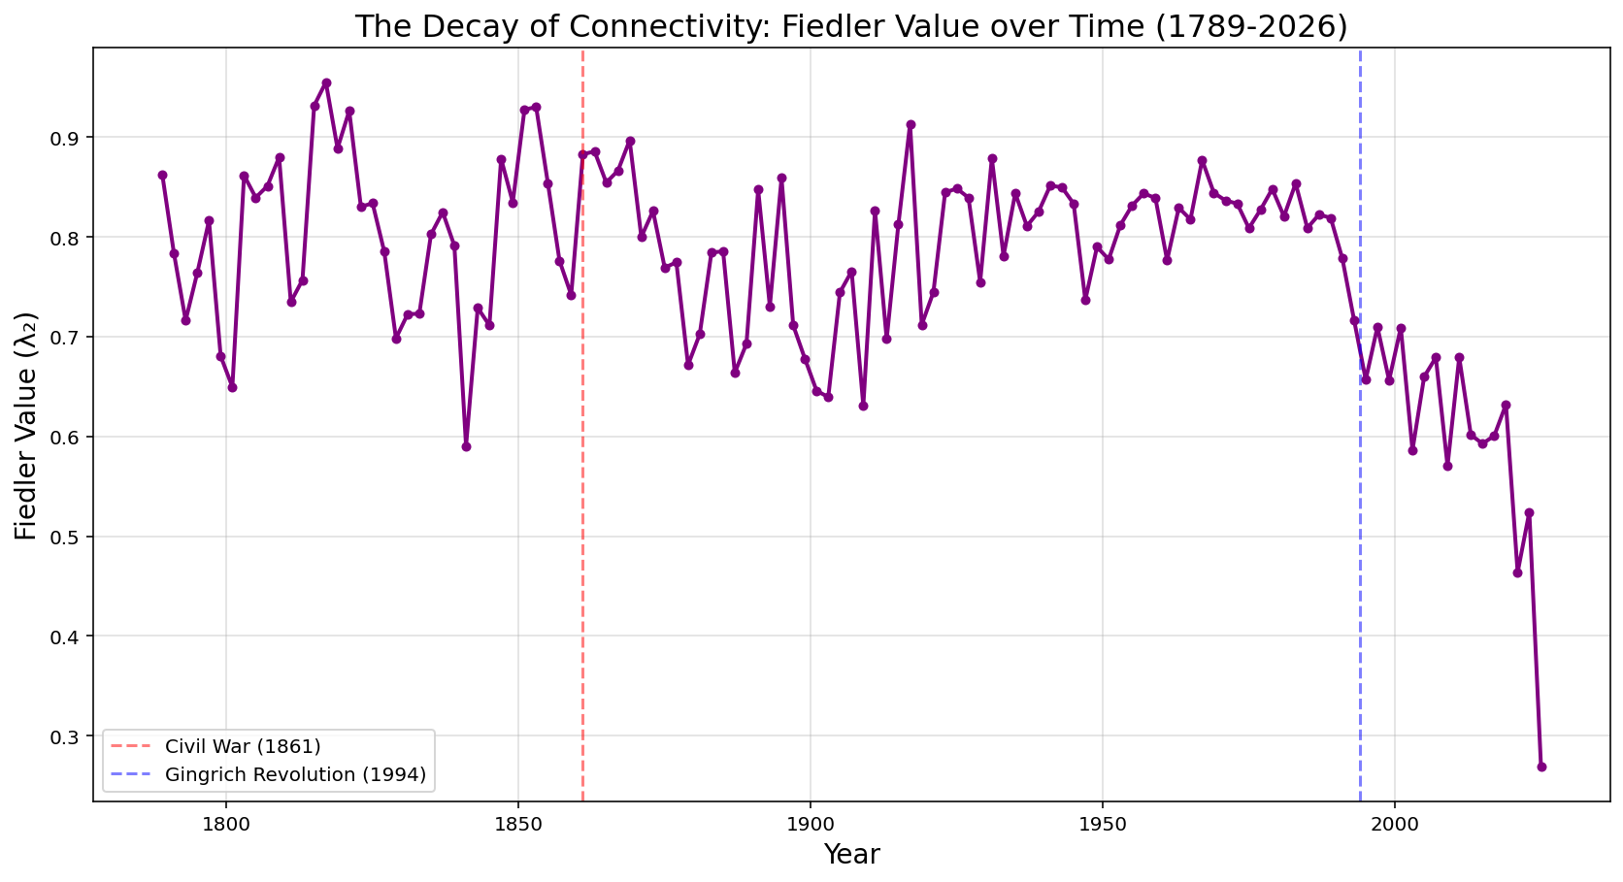
The US Senate has suffered a complete collapse in its Fiedler value, indicating a critical level of disconnectivity. The May 2026 Fiedler value is approximately 0.269, its lowest value in American history. This reflects a trend of decline since the 1994 Gingrich Revolution. While the Fiedler value provides an algebraic measure of network fragility, the empirical Cheeger constant (h_{G}) quantifies the physical severity of this bottleneck. By calculating the actual conductance of the Senate graph using a Fiedler vector sweep cut, we can observe the literal shrinkage of the chamber’s cross-aisle “surface area.” As visualized in Figure 5.2, the empirical Cheeger constant tracks the plunging Fiedler value perfectly.

Figure 5.2
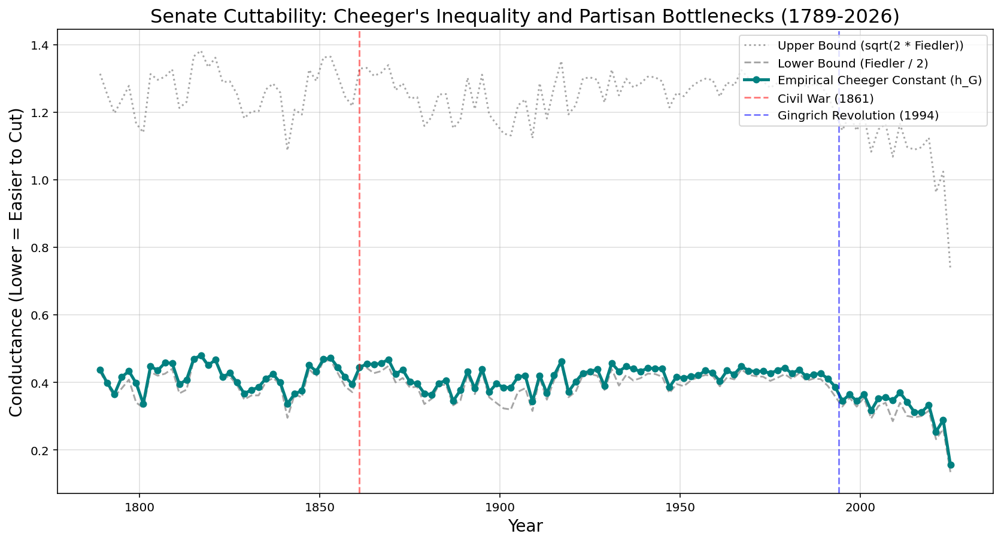
In the modern era, the actual physical ratio of interparty edges relative to intraparty edges has plummeted, forcing the empirical conductance to hug the floor of the lower bound of the Cheeger Inequality. This confirms that the physical volume of bipartisan legislation binding the two parties together has reached a historic minimum.
To visualize the physical reality of this plummeting Cheeger constant, we can reconstruct the Senate’s topology using 3D force directed network graphs. By establishing a strict edge threshold where connections are only drawn if the voting correlation exceeds 0.5, we can observe the literal severing of the chamber’s connecting edges. In Figure 5.3a, representing the 96th Senate (1979-1981), despite the threshold, the network resembles a densely connected structure. There is a very high volume of interparty edges which physically validates the high empirical conductance calculated earlier via Cheeger’s Inequality.

Figure 5.3a
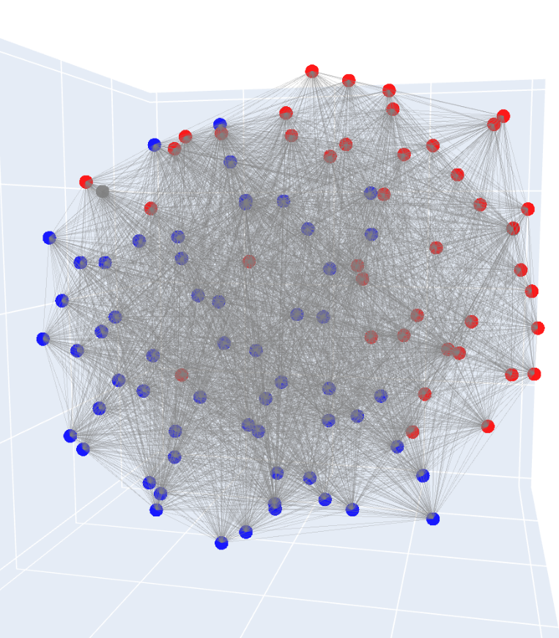
3D Force Directed Graph for the 96th Senate (1979-1981, edge correlation threshold = 0.5)

In Figure 5.3b, representing the 119th Senate (2025-2027), the network has literally completely fractured. Despite using the exact same correlation threshold, there is not a single edge bridging the Democratic and Republican clusters. The empirical Cheeger constant has functionally reached zero, visually confirming the alarm of disconnectivity raised by the Fiedler value discussed prior. We can clearly see that the Senate has structurally split into two distinct, unattached entities.

Figure 5.3b
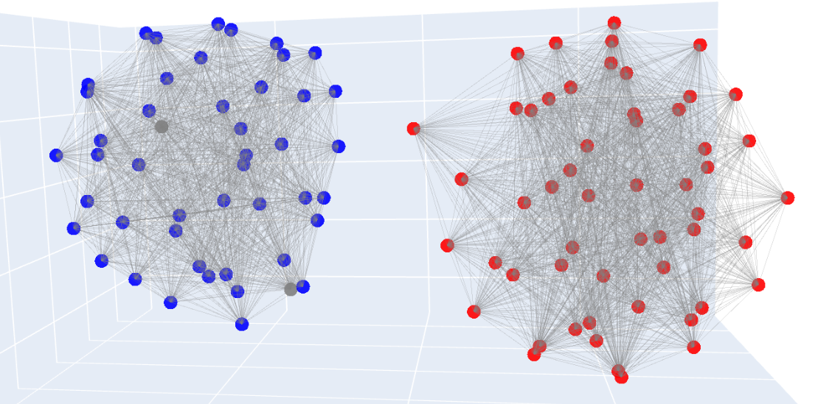
3D Force Directed Graph for the 119th Senate (2025-2027, edge correlation threshold = 0.5)

The dimensionality collapse is made especially clear by visualizing the 4 smallest eigenvalues (excluding λ₁ as this equals 0) between the 96th and 119th Senate. In Figure 5.4, the widening of the spectral gap is obvious.

Figure 5.4
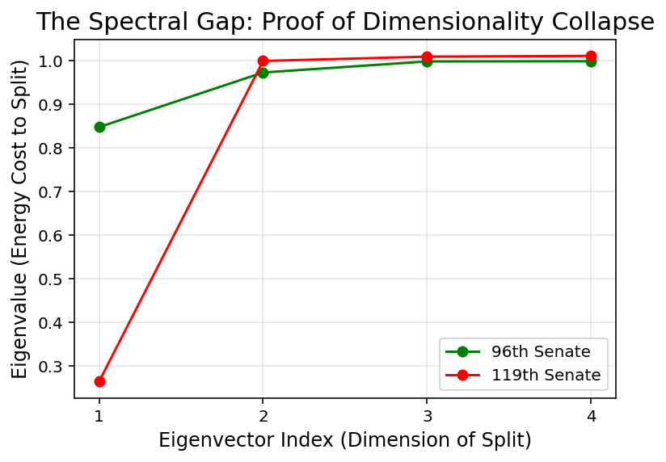
The consequential mathematical phase transition is then most clearly observed by visualizing the changing geometry of the Senate’s eigenvectors. By plotting the Fiedler vector (λ₂, representing the primary axis of division) against the third eigenvector (λ₃, representing the secondary dimension of division), we can visually track the phenomenon of conflict extension and dimensionality collapse. Consider the 2D spectral geometry of the 96th Senate (1979-1981) in Figure 5.5a.

Figure 5.5a
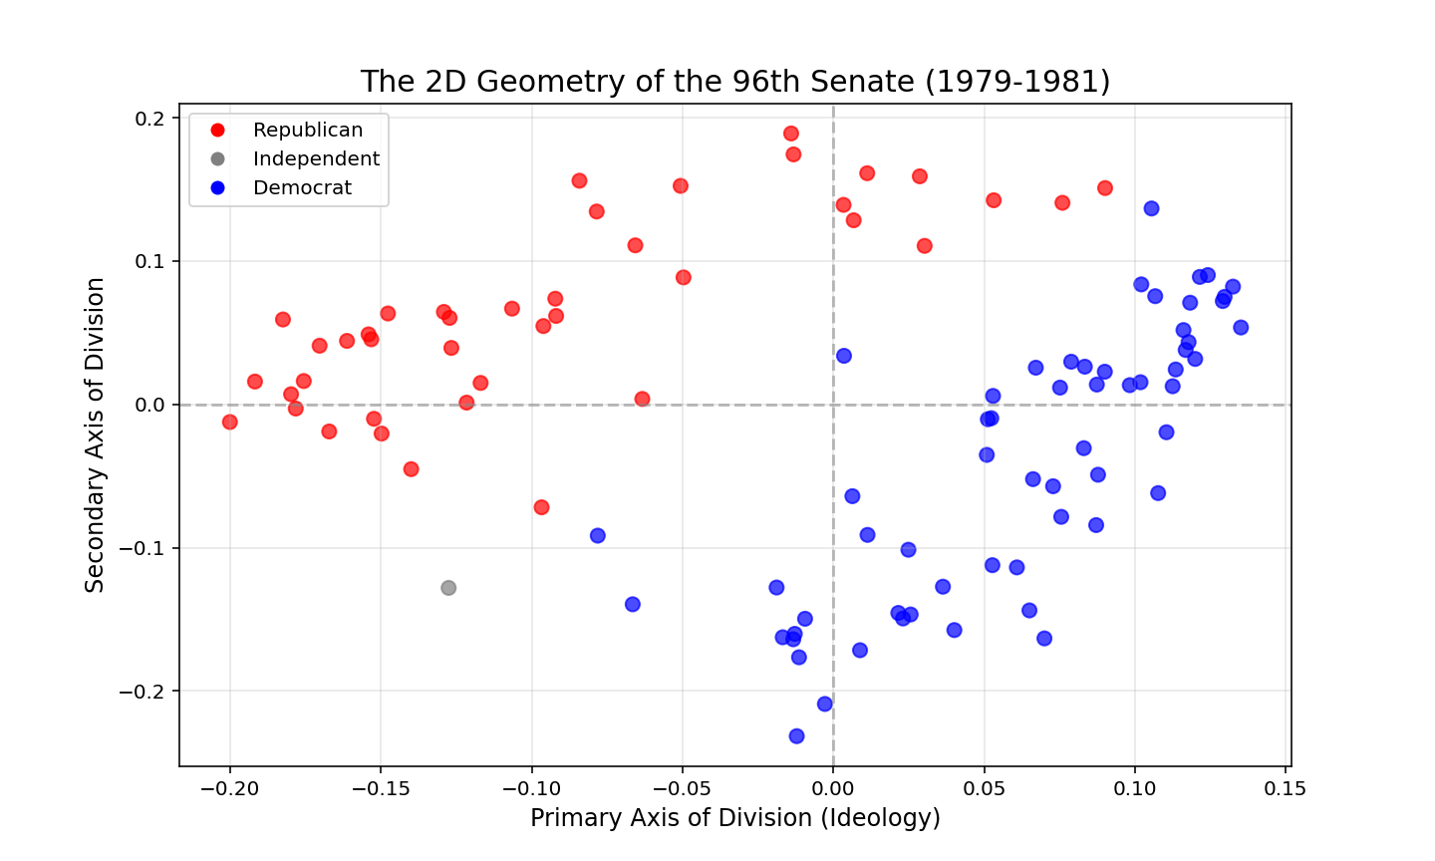
While the primary partisan divide (the X-axis) is present, the graph is characterized by a dispersed, cloud-like structure with significant variance along the secondary Y-axis as well. Furthermore, the ideological center is heavily populated by senators from both parties whose voting records overlap, blurring the boundary between the clusters. This indicates a multi-dimensional and healthy legislative environment where orthogonal issues such as regional interests or intra-party factions still dictate a significant portion of roll-call behavior, allowing for a dense web of cross-party bridges. In contrast, the geometry of the 119th Senate (2025-2027) in Figure 5.5b demonstrates a complete topological collapse.

Figure 5.5b
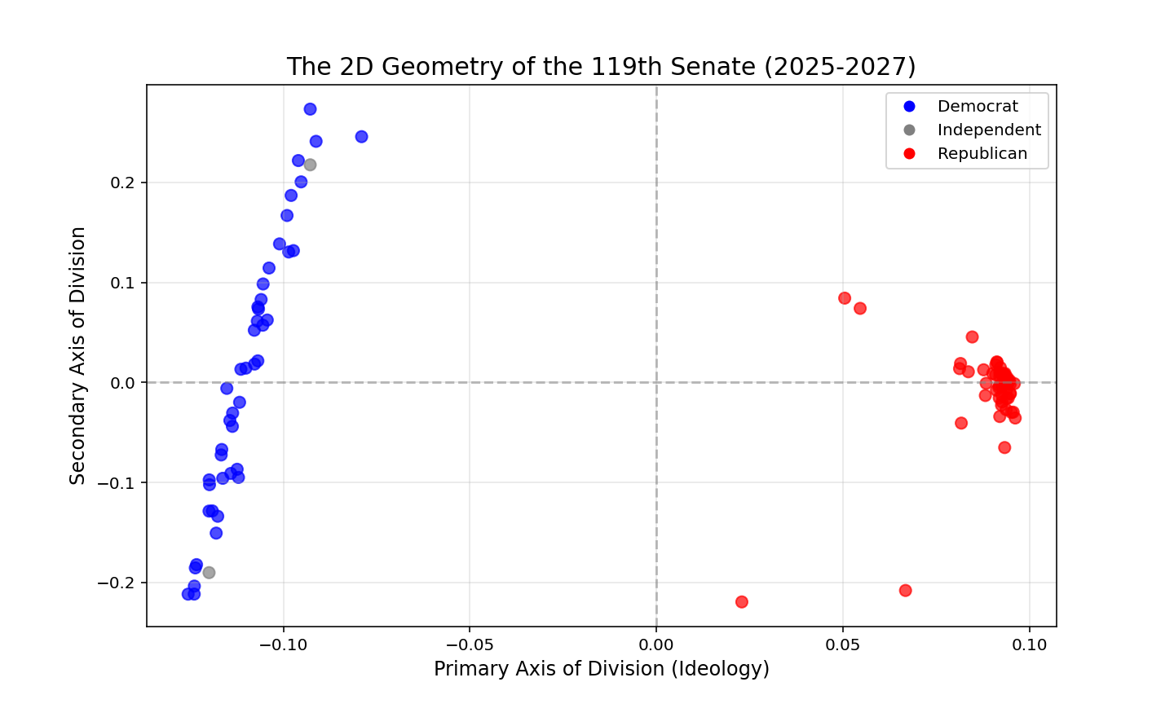
The dispersed cloud of the 96th Senate has hyper-compressed into two rigid clusters pushed to the absolute extremes of the primary axis. The ideological center is essentially entirely empty, with the closest Senators being Alan Armstrong (who just joined the Senate in March 2026), Lisa Murkowski, and Susan Collins. Additionally, the variance along the secondary dimension (λ₃) no longer represents a meaningful orthogonal axis of compromise between the two parties, but instead appears to primarily capture ideological division within the Democratic Party exclusively. Instead, it appears that all issues have been absorbed into the primary partisan divide. This is a perfect representative of the hypothesized one-dimensional bipartite graph. The geometric space for building bridges between parties has been almost completely erased.
Betweenness centrality (BC) is our secondary key variable, serving as a measure of the extent of “monopolization” of brokerage power in the Senate. In this network topology, a Senator’s betweenness centrality measures the frequency with which they sit on the shortest path between any two other nodes. When there are many Senators willing to cooperate, their individual brokerage power decreases in favor of creating a more unified network. When there are only very few Senators in the middle, these individuals hold a lot of brokerage power. The below chart plots the maximum betweenness centrality over time. We can see a long period of low maximum betweenness centrality spanning from the Great Depression to the 1990s, where it then spikes massively, indicating a loss of general connectivity and a degradation to “monopolized brokers” where compromise must be routed through a very small number of Senators which operate in the middle. This phenomenon is strikingly evident when plotting the maximum individual betweenness centrality over time, as seen in Figure 5.6.

Figure 5.6
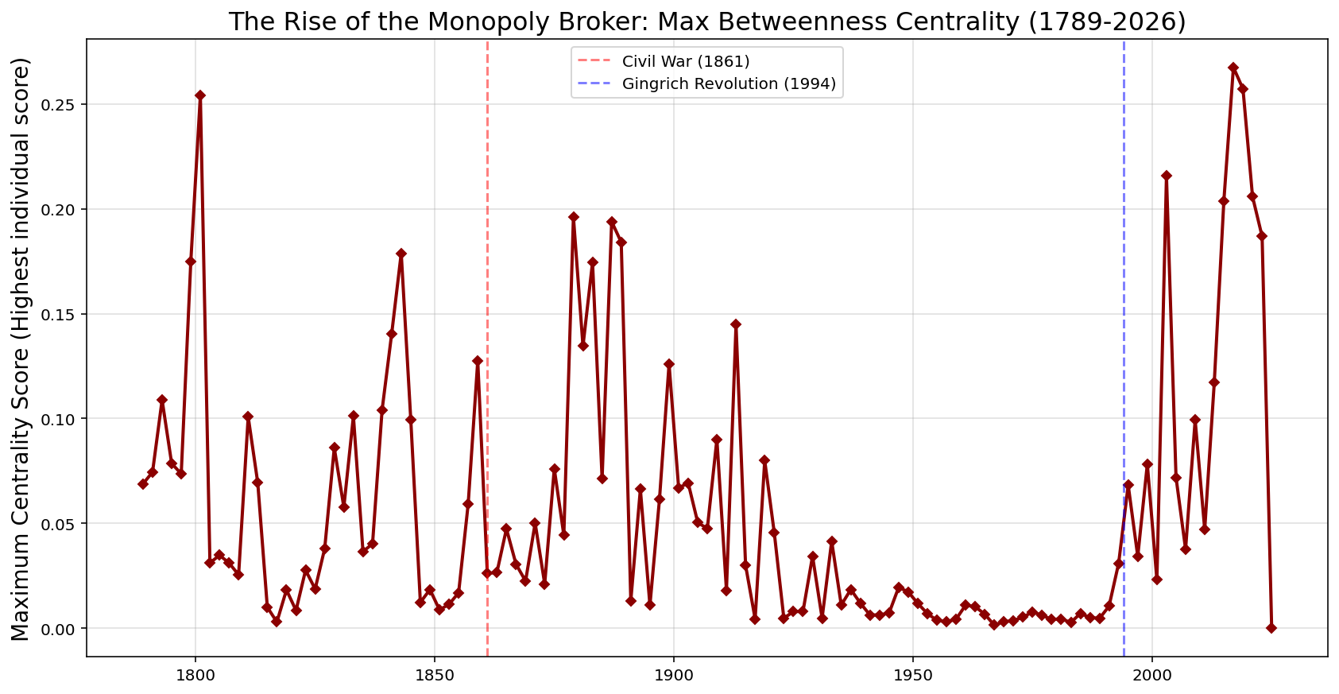
The data reveals a prolonged era of structural stability and distributed power stretching from the Great Depression through the early 1990s, characterized by consistently low maximum BC scores. Following the 1994 Gingrich Revolution, however, maximum centrality spiked massively. This indicates a severe degradation of general connectivity, forcing any cross-party legislative compromise to route through an increasingly isolated set of “monopoly brokers.” This trend continued for much of the 119th Senate, however, live data collected through May 2026 has revealed the terminal stage of this topological phase transition. In the most recent roll-call matrices, maximum betweenness centrality collapsed entirely to zero across the entire chamber. This is because the edge threshold was set at 0.5, and the voting similarity relationships in the Senate have soured to such an extent that now there no longer exists a single edge between the two partisan clusters.
To even better visualize the mechanics of this monopolization, we can examine the Senator-level distribution of brokerage power relative to primary ideology (the Fiedler vector) for specific Congresses. Consider the 96th Senate (1979-1981) in Figure 5.7a.

Figure 5.7a
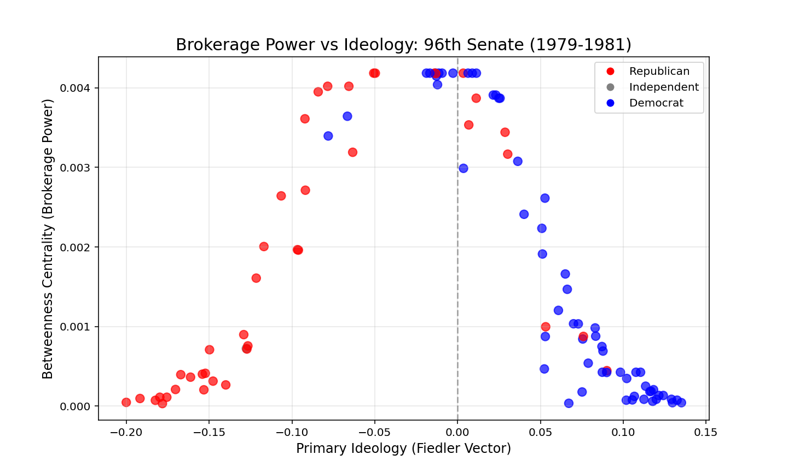
The distribution of betweenness centrality forms a clear inverted-U shape. A massive, bipartisan “middle class” of senators occupies the ideological center, collectively sharing the structural load of connecting the graph. Because there are so many viable pathways across the aisle, the maximum individual power remains low (peaking around 0.004). Consider the 119th Senate (2025-2027) in contrast in Figure 5.7b.

Figure 5.7b
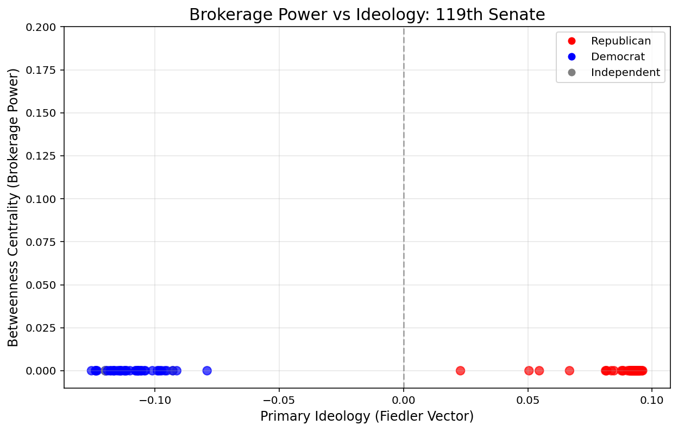
The extinction of the brokerage class in the 119th Senate is clearly evident. The ideological center is entirely hollowed out, leaving the entirety of the chamber with a betweenness centrality of nearly exactly zero. In 2025 and the early months of 2026, there was a set of Senators which occupied the middle and had an extremely high betweenness centrality, but in the most recent data from May 2026, this bridge has collapsed, and now there is not a single Senator with a significant share of betweenness centrality. This visual contrast clearly captures the topological phase transition where the capacity for compromise in the Senate has entirely dissolved. Now, we simply observe a bipartite graph where bridge-building is no longer an assumed institutional trait, but rather a rare circumstance only born out of Senators cooperating before bills are brought to the floor.

6 Results
This analysis set out to determine whether the United States Senate has undergone a topological phase transition, specifically testing if the Senate has collapsed from a multi-dimensional, connected space into a disconnected, one-dimensional bipartite graph. Furthermore, it sought to quantify how the distribution of brokerage power has shifted during this period, testing the hypothesis that modern legislative gatekeeping has become highly monopolized.
The eigendecomposition of the normalized Laplacian matrices from 1789 to 2027 provides overwhelming empirical support for the proposed alternative hypotheses. The primary metric of algebraic connectivity, the Fiedler value (λ₂), demonstrates an unprecedented structural collapse in the modern era. While historical Senates, including those preceding the American Civil War, maintained relatively high algebraic connectivity, the network underwent a sharp and sustained phase transition beginning in the mid-1990s. This decay culminates in the 119th Senate (2025-2027), which records a historically unprecedented Fiedler value of 0.269. Mathematically, an eigenvalue this close to zero indicates that the Senate’s relational topology has practically severed into two disconnected components. To grasp the practical severity of this structural collapse, it is informative to directly compare the network metrics of the 96th Senate (1979-1981) as a baseline of healthy multi-dimensionality against the 119th Senate (2025-2027). In the 96th Senate, the robust Fiedler value (λ₂ = 0.848) corresponded to an empirical Cheeger constant of h_{G} = 0.443, indicating that a full 44.3% of the minority cluster’s legislative ties crossed the partisan aisle. Consequently, the relaxation time ($\frac{1}{λ_{2}}$, the primary time constant which binds 𝜏_{mix}) remained incredibly low at roughly 1.2 steps, and the expected hitting time H(i,j) between a polarized Democrat and a polarized Republican was mathematically viable. By the 119th Senate, this topology is mathematically unrecognizable. As the Fiedler value plunges to 0.269, the empirical Cheeger constant collapses to h_{G} = 0.156, indicating that 15.6% of the minority cluster’s legislative ties crossed the aisle. This proves that the volume of cross-aisle bridges has effectively evaporated. Because the mixing time and hitting time are inversely proportional to the spectral gap, this Fiedler value causes the required steps for a random walk of persuasion to explode by a factor of 3.16. The relaxation time skyrockets to over 3.7 steps, and the expected hitting time between the opposing partisan poles approaches infinity. These precise comparative values definitively prove that cross-aisle persuasion has transitioned from a structural routine into a mathematical near-impossibility.
Simultaneously, the geometry of the eigenvectors confirms a complete dimensionality collapse. Analysis of the secondary dimension of division (λ₃) reveals that historical Senates possessed significant orthogonal variance, indicating that senators frequently voted across party lines based on overlapping, multi-dimensional interests. In the past, there existed a phenomenon like the “Southern Democrat,” which may suggest that this secondary axis could have corresponded to regional or geographic divides rather than strict party platforms. In the contemporary network however, variance along the secondary axis has vanished. The modern spectral geometry has been compressed into two mutually exclusive poles. This mathematically rejects the null hypothesis that the Senate is merely experiencing a “widening” of traditional spatial polarization. Instead, the connections themselves have fundamentally fractured, confirming the chamber’s topological transition into a strict, one-dimensional bipartite graph.
Finally, the analysis of shortest-path networks confirms the hypothesized shift in legislative brokerage power. Longitudinal tracking of Maximum Betweenness Centrality (BC_{max}) reveals that for the majority of the 20th century, the structural burden of connecting the network was distributed across a dense, bipartisan middle class, keeping individual monopoly power remarkably low. Following the 1994 Congress, however, BC_{max} increased massively. Fascinatingly, the 119th Senate completely reverses the trend: the spike in BC_{max} is inverted as it drops completely to zero. This is the result of the collapse of all bridges between the two parties given the edge correlation threshold of 0.5. This leaves the entire chamber with a bridging power of almost exactly zero. This phenomenon is a mathematically valid and expected outcome of a fully fractured topology. In order for a node to possess betweenness centrality, it must sit on the shortest path between two other nodes. In the 119th Senate, cross-aisle voting correlations have decayed below the threshold of connectivity, severing the graph into disconnected components and destroying all interparty paths. Simultaneously, hyper-partisan discipline has transformed the isolated party clusters into perfectly dense cliques, where intra-party paths are effectively entirely direct and require no methodical routing. With no interparty paths to bridge, and no internal paths to route, the role of the “broker” has been mathematically eliminated. However, if an edge is to reappear as the Senate continues, that small number of Senators will replicate the trend observed before the 119th Senate, once again increasing BC_{max} to historically high extremes. This drop to zero is an interesting artifact that demonstrates the extreme instability of the 119th Senate.
Collectively, these spectral and centrality metrics confirm the proposed hypotheses. The United States Senate has mathematically transitioned out of a fluid, multi-dimensional network and into a brittle, disconnected topology defined by the extinction of the distributed moderate broker and the rise of the monopolized gatekeeper.

Table 6.1
 | 96th Senate | 119th Senate
Fiedler Value (λ₂) | 0.848 | 0.269
Cheeger Constant (h_{G}) | 0.443 | 0.156
Relaxation Time ($\frac{1}{λ_{2}}$) | 1.2 | 3.7
Max Betweenness Centrality (BC_{max}) | 0.004 | 0

7 Discussion
The implications of this topological phase transition extend beyond the gridlock of the modern Senate. They are effectively an affront to the foundational political theory of the United States in its early history: in Federalist No. 10 (Madison 1787), James Madison diagnosed the “mortal disease” of popular governments as the violence of faction. Because the latent causes of faction are “sown in the nature of man,” Madison argued that the only cure was to control their effects by engineering a highly complex, multi-dimensional republic. By “extending the sphere” of the country, Madison theorized that the government would naturally take in a “greater variety of parties and interests,” or in other words, greater dimensionality in division. This Discussion seeks to elevate this math to democratic theory. What are the constitutional implications of a bipartite Senate?
The authors of the Constitution designed the Senate to be a continuous, overlapping network that forged consensus. In network terms, Madison proposed a system that relied on high algebraic connectivity. A healthy Madisonian republic requires a network where cross-cutting interests overlap, creating a high-dimensional topology where legislators frequently form constantly shifting coalitions that vary from issue to issue. This theoretical ideal is empirically visible in the spectral geometry of the mid-20th century Senate (such as the 96th Senate), where a high Fiedler value and a densely populated ideological center maintained the structural bridges necessary for fluid governance. Because interests were varied and orthogonal, no single faction could easily consolidate absolute power.
However, the spectral analysis of the contemporary Senate demonstrates that Madison’s primary defense mechanism has mathematically collapsed. The phenomenon of conflict extension has compressed Madison’s “variety of interests” into a single partisan binary. As the network’s Fiedler value approaches zero, it proves that the Senate’s multi-dimensional topology has been entirely flattened into a disconnected one-dimensional bipartite graph.
This structural severing of the Senate graph greatly alters how legislation must be engineered to pass. This can be mathematically modeled by conceptualizing the flow of legislative discourse in the context of random walks in Markov chain dynamics. In a connected topology like the 96th Senate, the hitting time, which is the expected number of steps for a random walk to travel from any node to another, is relatively small. A bill introduced by a single partisan sponsor had a high probability of organically traversing the network, flowing through moderate brokers to gather the cross-aisle consensus required for passage. The Senate operated as intended: as a unified, deliberative body where persuasion was topologically possible.
In the contemporary bipartite topology of the 119th Senate, this framework is effectively mathematically dead. Because the transition probabilities across the aisle are nearly zero, the hitting time between the two partisan clusters will approach infinity. Consequently, a bill introduced exclusively within one cluster will almost always become permanently trapped within that cluster in a closed random walk. If we set hard edge thresholds like in Figures 5.3a and 5.3b, this can be clearly observed by the complete lack of connecting edges between the two party clusters in the 119th Senate.
This topological reality is made even more problematic with contemporary Senatorial procedural rules. Specifically, the 60 vote cloture threshold for filibusters is a major site of friction. If a majority party holds fewer than 60 seats, a bill’s survival requires crossing party lines. Because a “random walk of persuasion” is no longer able to bridge the gap, debate on the Senate floor is structurally futile. The mathematics imply that the only viable method for passing major legislation in the modern era is through simultaneous sponsorship originating in both clusters. If a bill does not bypass the network’s broken topology by “spawning” organically on both sides of the aisle, it is mathematically practically guaranteed to fail. Ultimately, this yields a profound paradox: while the Constitution establishes the Senate as a single legislative body, its topology is operating as two distinct, disconnected components, rendering the chamber structurally incapable of fulfilling its institutional mandate.
This dimensionality collapse represents a constitutional crisis of structure. The modern Senate operates with the rigid, zero-sum factions of a parliament, but it remains constrained by contemporary rules, like the 60 vote filibuster cloture, designed for a fluid network like was proposed by Madison. This is where the metric of betweenness centrality starkly quantifies the breakdown of the legislative process. In a functioning network as proposed by Madison, brokerage power ought to be decentralized. The structural burden of compromise must be shared across a broad middle class of legislators, keeping individual betweenness centrality low.
However, the contemporary spike in Maximum Betweenness Centrality (BC_{max}) reveals the emergence of the absolute “monopoly broker.” When the connective tissue of the Senate is routed exclusively through one or two moderate nodes, these isolated individuals gain disproportionate, near-absolute leverage over the passage of any legislation. This is amplified now because the chamber often requires 60 votes to break a filibuster, so these monopolized gatekeepers effectively function as a necessary tollbooth to pass for the entire legislature. By effectively eliminating the moderate broker and routing all legislative power through a handful of monopolized gatekeepers, the Senate has evolved into Madison’s described nightmare: a system where a single, consolidated faction can consistently sacrifice the public good to its “ruling passion or interest.” The mathematical severing of the Senate graph confirms that the intended legislative mechanism which relies on overlapping and cross-party coalitions is no longer structurally viable.

8 Conclusion
The goal of this thesis was to determine if the United States Senate has undergone a topological phase transition, collapsing from a cohesive, multi-dimensional network into a disconnected, one-dimensional bipartite graph. By applying Spectral Graph Theory and shortest-path network metrics to over two centuries of roll-call voting matrices, the empirical results confirm a significant structural severing of the Senate.
The data reveals that following the 1994 Gingrich Revolution, the Senate’s algebraic connectivity, measured by the Fiedler value, suffered a catastrophic collapse, plummeting to a historically unprecedented 0.269 in the 119th Senate. This algebraic decay is mirrored by the complete elimination of the chamber’s moderate center. For the majority of the 20th century, the burden of compromise was distributed across a bipartisan moderate class made up of a large number of Senators on both sides of the aisle. Today, that network has vanished. Maximum betweenness centrality indicates that the role of the “moderate broker” was initially monopolized by an increasingly isolated handful of gatekeepers, before mathematically zeroing out entirely as the final cross-aisle bridges recently collapsed in the 119th Congress. Translated through the Markov chain dynamics of hitting time and mixing time (both bounded by the relaxation time), these metrics prove that the capacity for legislative persuasion to traverse the partisan divide by chance alone has mathematically collapsed. The relaxation time has increased by a factor of 3.7 since the 96th Senate.
The social science implications of these findings represent a profound crisis of democratic structure in the United States. The modern Senate operates with the rigid factions we might expect of a parliamentary system, yet it remains bound by procedural rules designed for a highly connected dynamic network. By mathematically proving that the Senate has fractured into disconnected components, this research demonstrates that the model of overlapping, cross-cutting interests proposed by James Madison has structurally failed. The Senate is no longer a single deliberative body, but it instead functions as two isolated entities whose decisions are entirely predictable along the single, partisan axis.

Limitations
The primary limitation of this thesis is born out of the data-generation process of the modern US Senate. As discussed in the Literature Review, modern roll call votes are essentially the product of a highly engineered process where a small number of bills are actually brought to the floor to be voted on. With roadblocks like the filibuster effectively necessitating modes like omnibus legislation, roll call votes are no longer representative of a purely unfiltered ideological space. One could argue that it instead represents a binary choice cultivated by respective party leaderships, possibly creating a faux image of ideological polarization, when metrics such as λ₂ are actually representing a combination of ideological polarization with the mechanical consequences of the reality of modern Senate procedure.
A potential measure of pure ideological division could be (and often is) derived from bill cosponsorship data. Because any Senator can cosponsor legislation with any other Senator, these networks are unconstrained by the procedural bottlenecks of floor voting. While using cosponsorship data would indeed eliminate these specific limitations, I intentionally selected roll call data to ensure that the findings of this network-based methodology remain directly comparable to the foundational spatial models like DW-NOMINATE that dominate the existing political science literature.
Another limitation of this thesis is the interpretability of axes derived from Spectral Graph Theory based analyses. While they remain meaningful, they lack the ease of interpretability offered by DW-NOMINATE’s axes. This is because of the mathematical nature of the normalized Laplacian matrix, and thus qualitative interpretation of the eigenvectors after the first will require a corresponding qualitative analysis of the Senate at that given time period.
Another key limitation is in the necessity to transform the range of values in the adjacency matrix from [-1, 1] to [0, 1] as Laplacian transformation cannot handle negative values. “0” effectively represents “no relationship at all,” when the reality of the Senate is that Senators which always vote against each other are “perfect political opponents.” The latter phenomenon is still a valuable relationship for interpretation that is not made available by this methodology.
This thesis proposes future research that expands the methodology from simple roll call voting to also include bill consponsorship to isolate the procedural changes in the Senate from ideology, and to determine if the topological collapse remains as apparently dramatic as the roll call results.

References
Fowler, James H. “Connecting the Congress: A Study of Cosponsorship Networks.” Political Analysis 14, no. 4 (2006): 456–87. https://doi.org/10.1093/pan/mpl002.
Froyland, Gary. “Spectral Geometry for Dynamical Systems and Time-Evolving Networks.” Society for Industrial and Applied Mathematics 58, no. 8 (2025). https://www.siam.org/publications/siam-news/articles/spectral-geometry-for-dynamical-systems-and-time-evolving-networks/.
Krutz, Glen S. Hitching a Ride: Omnibus Legislating in the U.S. Congress. Parliaments and Legislatures Series. Ohio State University Press, 2001.
Layman, Geoffrey C., Thomas M. Carsey, John C. Green, Richard Herrera, and Rosalyn Cooperman. “Activists and Conflict Extension in American Party Politics.” American Political Science Review 104, no. 2 (2010): 324–46. https://doi.org/10.1017/S000305541000016X.
Lovász, László. “Random Walks on Graphs: A Survey.” Combinatorics, Paul Erdos Is Eighty 2, 1993. https://cs.yale.edu/publications/techreports/tr1029.pdf.
Madison, James, Alexander Hamilton, and John Jay. The Federalist Papers. Repr. Edited by Isaac Kramnick. Penguin Classics. Penguin, 1988.
Matthews, Donald R. “The Folkways of the United States Senate: Conformity to Group Norms and Legislative Effectiveness.” American Political Science Review 53, no. 4 (1959): 1064–89. https://doi.org/10.2307/1952075.
McCarty, Nolan M., Keith T. Poole, and Howard Rosenthal. Polarized America: The Dance of Ideology and Unequal Riches. Online-Ausg. EBL-Schweitzer. MIT Press, 2006.
Poole, Keith T., and Howard Rosenthal. “A Spatial Model for Legislative Roll Call Analysis.” American Journal of Political Science 29, no. 2 (1985): 357. https://doi.org/10.2307/2111172.
Schoch, David, and Ulrik Brandes. “Legislators’ Roll-Call Voting Behavior Increasingly Corresponds to Intervals in the Political Spectrum.” Scientific Reports 10, no. 1 (2020): 17369. https://doi.org/10.1038/s41598-020-74175-w.
Sinclair, Barbara. Unorthodox Lawmaking: New Legislative Processes in the U.S. Congress. 5th edition. CQ Press, 2017.
Theriault, Sean M., and David W. Rohde. “The Gingrich Senators and Party Polarization in the U.S. Senate.” The Journal of Politics 73, no. 4 (2011): 1011–24. https://doi.org/10.1017/S0022381611000752.
Wawro, Gregory J., and Eric Schickler. Filibuster: Obstruction and Lawmaking in the U.S. Senate. 2. printing and 1. paperback printing. Princeton Studies in American Politics. Princeton Univ. Press, 2007.
Zhang, Yan, A. J. Friend, Amanda L. Traud, Mason A. Porter, James H. Fowler, and Peter J. Mucha. “Community Structure in Congressional Cosponsorship Networks.” Physica A: Statistical Mechanics and Its Applications 387, no. 7 (2008): 1705–12. https://doi.org/10.1016/j.physa.2007.11.004.

